**Project Design Phase**

**Problem – Solution Fit Template**

| Date | 21 June 2025 |
| --- | --- |
| Team ID | LTVIP2025TMID39799 |
| Project Name | Clean Tech: Transforming waste into Transfer Learning |
| Maximum Marks | 2 Marks |

**Problem – Solution Fit Template:**

Manual blood cell classification is time-consuming, prone to human error, and requires expert pathologists. This leads to diagnostic delays and inconsistencies, especially in rural or resource-limited areas.

**Clean Tech: Transforming waste into Transfer Learning Purpose:**

* Solve complex problems in a way that fits the state of your customers.
* Succeed faster and increase your solution adoption by tapping into existing mediums and channels of behavior.
* Sharpen your communication and marketing strategy with the right triggers and messaging.
* Increase touch-points with your company by finding the right problem-behavior fit and building trust by solving frequent annoyances, or urgent or costly problems.
* **U.nderstand the existing situation in order to improve it for your target group**

**Template:**

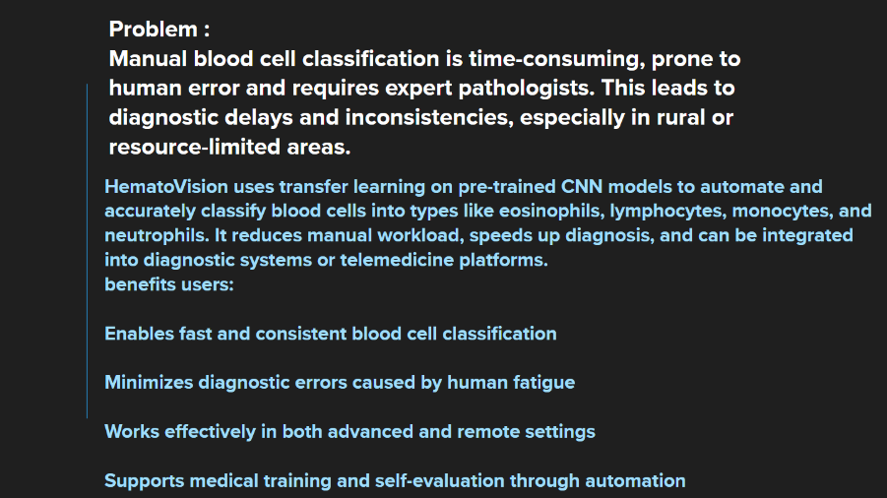

References:

1. <https://app.mural.co/t/smartbridgeaiml4943/m/smartbridgeaiml4943/1750999235365/2f2af4079bd6dbe26bcf23e2ce72c81c53d081ba?sender=u76a86db234d9bfb11e916073>